Manufacturing enterprise registration No.：鄂汉食药监械生产备20140029号
Product Registration number：鄂汉械备20140113号
Implementation Standard：YZB/鄂汉0087-2010

Operating Instruction of the JT-12K Automatic Biologic Tissue Dehydrator

Wuhan Junjie Electronics Co.Ltd

Tel：027-87401756 87411993 Fax：027-87411995
Web：www.whjjbl.com Chinese Website：病理器材
E-mail：junjiedianzi@126.com Postcode：430074
Address：Wuhan East Lake New Technology Development Zone,Wuhan University of Science and Technology Industrial Park , North Building

Foreword
The instruction of the JT-12K Automatic Biologic Tissue Dehydrator complies with the General National Standards of Industrial Product Manual and the Regulation of Medical Device Packaging to introduce the product’s structure,performance,operation and service life,and also to explain the product labels,graphics,symbols,etc.
The life expectancy of the Automatic Biologic Tissue Dehydrator is 6 years.

一.Summary
The Automatic Dehydrator can be used to process plant or animal tissues to make them dehydrated,transparent and wax-impregnated according to programs ,which is widely used in medical colleges and universities , animal and plant studies for pathology study and diagnosis .
二.Features
1．Convenience Chinese menu LCD touch screen, man-machine conversation operating system .
2.Metal-sprayed surface, high strength and corrosion resistance,and distinctively elegant with smooth lines.
3.With the combination of wire rope drive and computer control technology, the system is stable, accurate and quiet.
4.The system can store 20 sets of different procedures, to meet the requirements of different treatments.
5.Time opening and automatically record the complete time ,allowing you to finish your work within the given time.Automatically controlled fan can be at full function when the basket is up,and 10 s/min when the basket is down.
6.Environmental friendly external exhaust:Harmful gases will be exhausted to the outside directly through the pipe.
三.Main Technical Parameters
1.The numbers of hydraulic cylinder：12（the last three are paraffin wax cylinders）
2．The volume of one single cylinder：1800 mL
3．Processing time of a single cylinder：optionally between 0h～99h
4．Preset temperature：0～99℃
5．Time for filtrate and cylinder change：optionally between 10-60s，cylinder 1-7 are adjustable Power failure protection cylinders.
6. Automatically controlled fan can be at full function when the basket is up,and 10 s/min when the basket is down.
7. Number of preset programs：20 sets
Mixing speed：0-6 times per minute when powered by the power grid, and 1 time per minute at internal power supply.
9．Voltage ：AC220V±22V 50 Hz±1Hz Power：800W
10.Outline structure ：1250cm×490cm×490cm

Instruction ：
一．Turn on the power switch（the green light indicates the battery is turned on, the red light indicates AC power is turned on）； the machine will not start work when only the green light is on but the red light isn’t! When the red light is on ,it starts to work and automatically charge the battery. The battery can automatically maintain and protect the tissues for 10h~24h when there is a power failure during operation. After the power supply is resumed,the time needed to recharge the battery will be 10~72h ,depends on circumstances.
Please prepare back up batteries in areas where power failure is frequent.
二．After the start up ,the screen will display the machine type and name, company name, telephone and address, website and other basic information for about 10 seconds. Then entering the initialization phase, the basket mechanism will return to the bottom of the first cylinder,and complete the initialization phase. This stage can only be stopped by turning off the power.
As shown below:
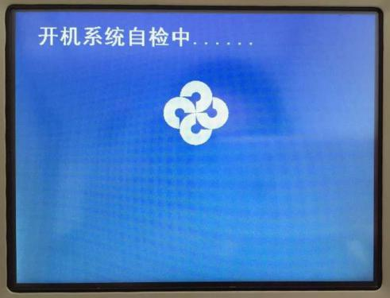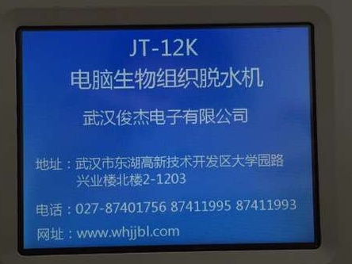

三．Enter the main menu interface after the initialization.Enter the programs of Programming,Settings ,Operation,and Help respectively,and hand-operate the basket mechanism in the main menu interface to move it up and down ,forward and backward.
As shown below:

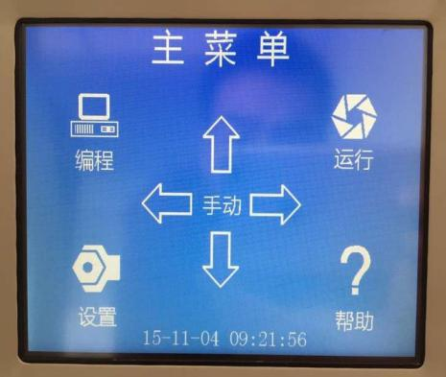

In the Programming interface,the time of 12 cylinders in 20 sets of programs can be programmed separately. As follows: ：touch the icons of“Adjust the sequence of the programs”、“Adjust the position of the cylinders”、“Adjust the hour”、“Adjust the minute”，when an icon is selected,touch the“+”、“-”for plus and minus operation. The maximum time allowed for each cylinder is 99h59min.
Also,touch the “Settings”、“Operation”、“Back”in the Programming interface to enter the interfaces of “Settings”、“Operation”、“Back”respectively.
As shown below:
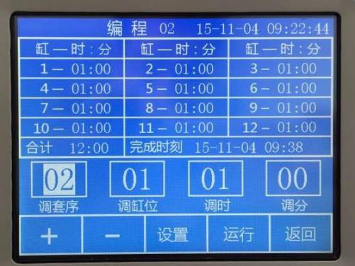

In the Settings interface,the temperature of wax,stay back to cylinder（1-7c optional），mixing frequency（1-6per minute optional）、time for filtration（10-30s optional）、time to start（optional），and the system time can be set.
As follows：touch the icon of “Adjust the time of the year-month -day hour:minute”，when it is selected,touch the“+”、“-”for plus and minus operation. The data cannot be changed if entering the Settings interface after the star-up of the basket mechanism. Also, touch the “Programming”、“Operation”、“Back”in the Settings interface to enter the interfaces of “Programming”、“Operation”、“Back”respectively.
As shown below:
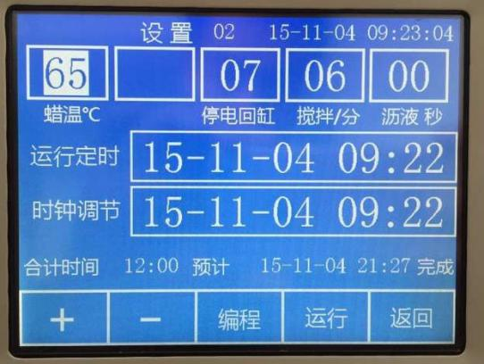

六．In the Operation interface,the program information can be viewed overall. Touch the “program +”、“program -”to choose program,touch the “Confirm”to store all the programmed data and have the basket mechanism run the selected program. Also,touch the “Programming”and“Back” to enter the interfaces of “Programming”and“Back”respectively.
As shown below:
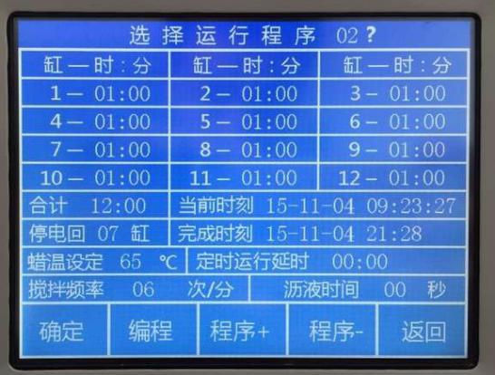

The Help interface explains the the operation of various parts of the machine.Touch the "previous page", "next page" to turn the pages. Also, touch the "Programming", "Settings", "Back" to enter the interfaces of "Programming", "Settings", "Main Menu" respectively .
As shown below:
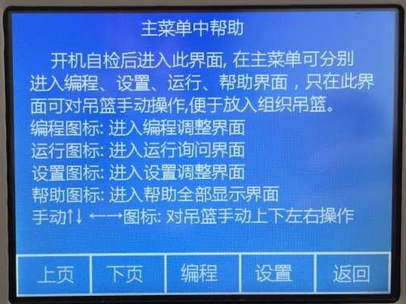
After it starts to operate,the wax cylinder will be heated,and the screen will show the temperature of wax,the number of the operating cylinder,and the remaining time. During immersion,the cylinder can be manually raised for observation and manually let down to continue the operation. If the power fails when the 9th cylinder procedure is finished,the basket mechanism will return to the protection cylinder set in advance,and will continue the operation after the power is resumed and the wax is heated to 58 ℃ .
As shown below:

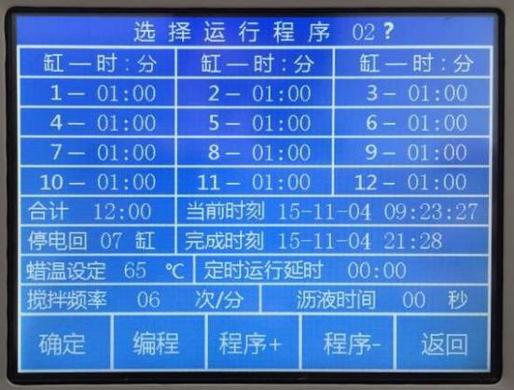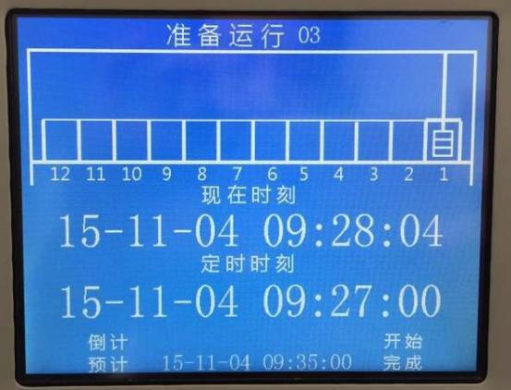

九．When the basket mechanism complete the task,the screen will show the icon to raise the cylinder ,touch the icon to get the tissues. When all the tasks are completed ,the screen will show the icon of Reset ,please take down the tissues and reset the machine,or restart it after turning off the power for 2 seconds to reset the machine.
As shown below:
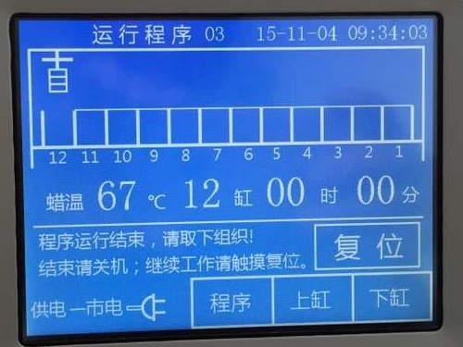
- Attention
1．When pressing the“up” button while the machine is running normally , don’t press the “ reset”button or cut off the power . If the power fails after entering the wax cylinder ,the timekeeping will be stopped.
2．Do not run the machine for more than 6 hours without power supply,and recharge it in time after operating without power supply . Charge method：under normal circumstances,the machine charges automatically while dehydrating.
3.The machine must be adequately grounded,and if it is not to be used for a long time,please unplug it.
4．If the machine malfunctions,please contact our company in time.Do not attempt to disassemble the equipment.
5、Organic reagent should be avoided entering the machine .Do not add reagent in operating mode.
6.Do not touch the screen with hard objects .
- Malfunction Analysis and Disposal

Code | Failure Phenomenon | Cause Analysis | Corrective Measures
1 | No indication of power | Fuse burning or unreliable power supply connection | Replace the fuse or power cord
2 | No display on panel | Burning of fuse | Replace the fuse
3 | Motor power shortage | Loosen motor plug | Tighten the plug

十一.Maintenance
1． The machine should be laid flat on a relatively fixed position, and be adequately grounded and have access to ventilation.
2.It is suggested that the machine should be kept clean.
3．It is suggested that the basket should be correctly hanged to avoid the malfunction of the cylinder.
4．Under normal use and maintenance, the life expectancy of the dehydrator is 7 years

Packing List

JT-12K

Machine 1
Basket 1
Protective tube（3A） 2
Power cord 1
Ventilation connector 1
Ventilation pipe 1
Ventilation pipe fittings 1
Instruction 1
certification 1
Customer feedback 1
Acceptance report 1
Packing list 1

Customer Feedback
User |  | Model
Salesperson |  | Contract NO.
Consignee |  | Date
Degree of satisfaction :
Excellent □ Good□ Poor □ Please mark with“√”
Attention and customer feedback
1.After unpacking the machine,is there any damage?Are the accessories documents and spare parts complete?

2.Are you satisfied with the installer’s introduction of the usage and instructions?

3.Please share with us any other information you would like to help us to improve the product.

Signature ：
Date :
Please fill in the form and give it to the installer or fax or mail it to our company to become our registered user.
Wuhan Junjie Electronics Co.Ltd
Equipment Acceptance Report
Device Name |  |  |  | Device Model
User’s name |  |  |  | User’s address
Department |  | Director |  |  | Tel
 |  | User |  |  | Tel
Date of arrival |  |  |  | Contract No.
Installation | After installation,testing and adjustment, the machine function reached the contract requirements and can be put into use .  Installer’s signature:  Date :
Acceptance  Check | The equipment is well packaged with complete accessories.After installation,testing and adjustment, the buyer prove that each machine function reached the contract requirements and the performance is good and acceptable.  Signature : Hospital’s official seal :  Date :

Wuhan Junjie Electronics Co.Ltd
Tel：027-87401756 87411993 Fax：027-87411995
Web：www.whjjbl.com Chinese Website：病理器材
E-mail：junjiedianzi@126.com Postcode：430074
Address：Wuhan East Lake New Technology Development Zone,Wuhan University of Science and Technology Industrial Park , North Building

